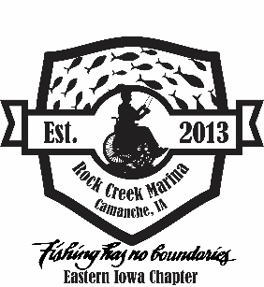
FISHING HAS NO BOUNDARIES
EASTERN IOWA CHAPTER
Lake Malone, DeWitt
June 13th, 2026

VOLUNTEER REGISTRATION FORM

NAME: _____________________________________ PHONE: _____________________
ADDRESS: __________________________________ CITY: __________________________
STATE______ ZIP ___________ EMAIL: _______________________________ T-SHIRT SIZE: ______
DO YOU HAVE EXPERIENCE WITH FISHING? YES / NO ___________________________________
DO YOU HAVE EXPERIENCE WORKING WITH CHILDREN WITH DISABILITIES? YES / NO
If yes, what experience? ___________________________________________________________
Please check below preference of volunteer options (may not be guaranteed but will be taken into consideration). Fishing buddies do not need to have fishing experience. All volunteers are able to fish as well, although priority is to assist anglers with disabilities and make this a memorable, fun experience (IA residents it is free fishing in Iowa weekend, IL residents need to purchase Iowa fishing license).
___________ Fishing buddy (partnered up with a participant)
___________ Misc. help (such as food, registration, parking, cleanup, etc.)
A sack lunch will be provided towards the end of the event, catered by Matthiessen’s. Please indicate what kind of sandwich you would like.

____ Turkey ____ Ham ____ Turkey & Ham ____ Veggie ____ I do not wish to have a sack lunch
Volunteer orientation is 9 am the day of event (June 13th, 2025) at Lake Malone, south of DeWitt (2524 330th Ave. DeWitt, IA) – all volunteers MUST ATTEND

Release of claims: In acceptance of my participation in the FHNB fishing event on June 15th, 2024, I release FHNB, Inc. and Lake Malone, the city of DeWitt, Clinton County Conservation, Clinton County and all respective agents and employees of the aforementioned and all others connected with this event, from any liability or claims for any injury to body, property, or illness that I sustain during my participation in this event. I understand that this release applies to myself, heirs, and anyone in participation with me. I am capable of participation in this Fishing Event for Individuals with Disabilities, recognize that risk of injury may accompany such participation and acknowledge that this release is being relied up on by the above person in permitting me to participate. I grant full permission to any and all related during the Event to use any photographs, movies, recordings, and other records of this Event without
compensation.

Please return form by June 10th, to the following address below or via email @ eifhnb@gmail.com:
Eastern Iowa – FHNB
PO Box 442
DeWitt IA 52742

If you have any questions, please call Jill @ 563-349-8680. Please understand the date is subject to change due to weather

SIGNATURE:_______________________________________________ DATE:_______________________

