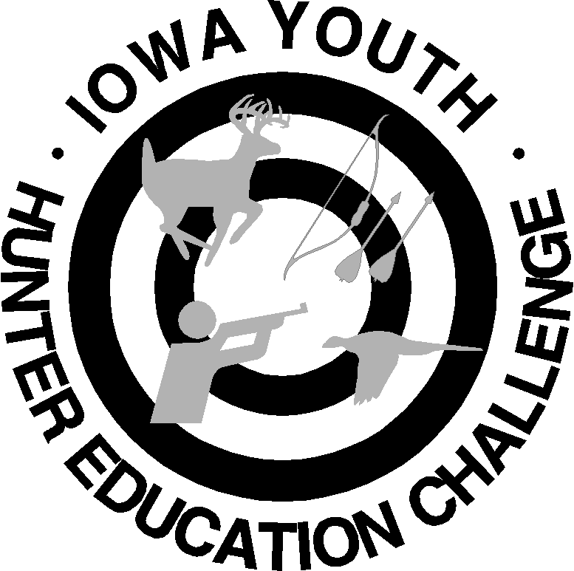
Liability/Medical Form
Check One: Junior Senior
Check One: Individual Team
Iowa State (NRA)
Youth Hunter Education Challenge

Participant Information (please print clearly)
Last Name: _______________________ First: ________________ M.I. ____ DOB: ______ Age: ______ T-Shirt Size: _____
Street Address: _________________________________ City: _______________________ State: _______ Zip: _________
Phone: ______________________ Email (for main correspondence): _________________________
Number of year(s) in the program: ______

Emergency Contact (first & last name): ________________________________ Relationship: __________________
Phone: ______________________________ Health Insurance Provider: _________________________________________
I, the Parent or Legal Guardian of (minor) _, give permission for emergency medical treatment of my son/my daughter for illness or accident if I cannot first be contacted. Yes No
Special Medical Considerations (i.e., medications, allergies, physical accommodations): ____________________________________________________________________________________________________________________________________________________________________________________________________________________
Liability/Medical Release:
Safety precautions, recommendations and regulations will be in place at all times during the (NRA) Iowa State Youth Hunter Education Challenge (YHEC) event.

The parent/legal guardian(s), by signing below, recognize that the program involves some risk and that
she/he takes responsibility for all actions or injury that may result in participating.

I, __________________________________ (parent/legal guardian name), hereby release, waive, discharge
and covenant not to sue the Clinton County YHEC, County of Clinton, Clinton County Conservation Board, or other agencies, partners, cooperating landowners, event volunteers and coordinators, sponsors, and any of the offices,
servants, agents and employees of the above-mentioned entities (hereinafter referred to as “RELEASEES”)
for any liability, claim and/or cause of action arising out of or related to any loss, damage or injury,
that could lead to death during the (NRA) Iowa State YHEC event.

I agree to indemnify and hold harmless the RELEASEES whether injury is caused by the negligence of the
RELEASEES or the negligence of any third party. I further agree that this Release and Waiver of Liability
shall bind the members of my family and spouse, if I am alive, and my heirs, assigns and personal
representatives, if I am deceased, and shall be deeded as a RELEASE, WAIVER, DISCHARGE AND
COVENANT NOT TO SUE the above-named RELEASEES. I hereby further agree that this Release and
Waiver of Liability shall be construed in accordance with the laws of the State of Iowa.

- Participants understand that photographs may be taken during the program and may be used in the future to
chronicle and publicize the program.

See reverse side for signature

By signing this Release and Waiver of Liability, I state that I have read and
understand the conditions set forth in this Release and that I agree to all conditions
set forth herein, and that I sign this voluntarily.

I/we (name(s) of parent/legal guardian) ______________________ authorize (name of child) _______________________
to be accompanied by all certified YHEC Coordinators and Volunteers throughout the event.

Signature(s) of Parent/Legal Guardian_____________________________________________________

Printed Name(s) of Parent/Legal Guardian___________________________________ Date_________

Please email registration form to jschmidt@clintoncounty-ia.gov or mail to CCCB, Attn: Jill Schmidt, PO Box 68, Grand Mound, IA 52751 by May 31, 2026 to ensure a spot.

