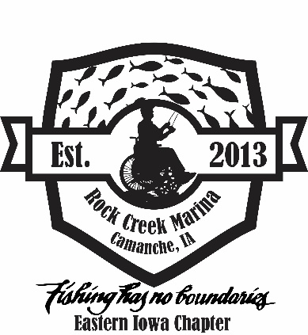
FISHING HAS NO BOUNDARIES
EASTERN IOWA CHAPTER
ROCK CREEK MARINA & CAMPGROUND
August 8th, 2026
PARTICIPANT REGISTRATION
Participant Fee $25
Attendant/Staff/Guest Fee $20
PARTICIPANT NAME: _________________________________________ AGE____________
GUEST/ASSISTANT NAME: __________________________________________________
STAFF NAME: ______________________________________________________________
AGENCY: __________________________________________________________________
PHONE: ____________________________________________________________________
HAS THE ANGELR PARTICIPATED IN A FHNB EVENT BEFORE? YES/NO
IF POSSIBLE, DOES THE ANGLER HAVE A REQUEST FOR A BOAT CAPTAIN AND/OR VOLUNTEER FISHING BUDDY? YES/NO
IF YES, PLEASE NAME: ____________________________________________________________
ADDRESS: ____________________________________________________ SEX: _____________
CITY: _______________________________ STATE: _______________ ZIP: _________________
CONTACT PHONE: __________________________________ T-SHIRT SIZE: _______
EMAIL: _______________________________________________________________________
EMERGENCY CONTACT AND PHONE: _____________________________________________________
DISABILITY: _______________________________________________ VETERAN? YES / NO

WILL PARTICIPANT BE IN WHEELCHAIR? YES / NO
*Note: wheelchairs will NOT be supplied at event
*Note: per National FHNB, no electric wheelchairs will be allowed on boats. Participants in electric wheelchairs will be able to fish from shore.
*Participants may transfer into a manual chair from electric chair depending on participant and safety regulation to fish by boat.
I PREFER TO FISH FROM ____ LAND _____ BOAT
*Note: fishing preferences will be based upon receipt of registration forms
*If requested preference is not available, participant will be contacted and given the option to switch preference
PLEASE REFER TO THE BACK OF THIS FORM

ASSISTANT/STAFF: The person who must accompany a participant at all times and is responsible for ALL needs on and off the water.
GUEST: The person who will be attending the meals and other on-ground activities with a participant. This includes all family and friends (including children) who will be joining us for the meals.

RELEASE OF CLAIMS: In acceptance of my participation in the FHNB fishing event on August 8th, 2026, I release FHNB, Inc. and Rock Creek Marina & Campground, the city of Camanche, Clinton County, and all respective agents and employees of the aforementioned and all others connected with this event, from any liability or claims for any injury to body, property, or illness I sustain during my participation in this event. I understand that this release applies to myself, heirs, and anyone in participation with me. I am capable of participating in this Fishing Event for Individuals with Disabilities, recognize that risk of injury may accompany such participation and acknowledge that this release is being relied upon by the above person in permitting me to participate. I grant full permission to any and all related people during the event to use any photographs, movies, recordings, and other records of this event without compensation.
Please plan on arriving between 8 – 8:30 am to register and receive your assignments for the event. If you need to arrive later than this time, please let me know.
PARTICIPANT SIGNATURE: ______________________________________ DATE ___________
(or legal guardian signature)
ASSISTANT/GUEST/STAFF SIGNATURE ___________________________ DATE ___________
WHERE DID YOU HEAR ABOUT THIS EVENT? _____________________________________________________________

IMPORTANT INFORMATION
· EACH PERSON WHO WILL BE ACTIVILY FISHING DURING THIS EVENT IS REQUIRED TO
POCESS A LEGAL IOWA FISHING LICENSE PRIOR TO THE EVENT
· WATERCRAFTS ARE FOR PARTICIPANTS AND NECESSARY ATTENDANTS
· ALL MINORS MUST BE ACCOMPANIED BY AN ADULT
· ABSOLUTELY NO ALCOHOLIC BEVERAGES OR CHEMICAL SUBSTANCES ARE PERMITTED
· IF YOU INTEND TO BRING YOUR OWN WATERCRAFT, COMPLETE A BOAT OWNER FORM
· IF YOU HAVE MEDICAL OR SPECIAL NEEDS, COMPLETE THE MEDICAL NEEDS FORM
· DISRUPTIVE/INAPPROPRIATE BEHAVIOR WILL BE DEALT WITH ON AN INDIVIDUAL BASIS.
COMPLETE AND RETURN WITH A CHECK NO LATER THAN July 26th, 2026, TO:
FHNB – Eastern Iowa Chapter
PO Box 442
DeWitt, IA 52742
OR VIA EMAIL: eifhnb@gmail.com
If forms are incomplete and/or a payment is not received the registration will not be considered.

