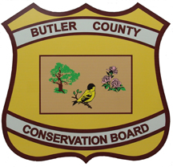
Butler County Conservation Board
Camp Parental Authorization and Release Form
Must be completed, signed and returned to Butler CCB by parent/guardian.

Camper Name _____________________________________________________

I _________________________________________desire ____________________________ to go
(Parent/Guardian Name and Relationship) (Child Name)
on any and all field trips and participate in any and all activities associated Butler County Conservation Board Camp during the summer of 2026.
____ I hereby give permission for medical professionals to provide emergency services to my child if necessary and agree to hold the Butler County Conservation Board, staff and their volunteers harmless of any said illness, injury or disease while participating in camp activities.
____ I understand that the Butler County Conservation Board is not financially responsible for emergency care or transportation, and it is my responsibility to inform conservation staff of all allergies, medications or physical limitations prior to the event.
____ By signing this agreement, I understand and agree that my child will abide by the general rules of conduct and that violations may result in denial of future privileges, a forfeiture of fees and immediate removal from the program activities.
____ I also give permission for my child to be photographed by Butler County Conservation Board staff or media to be used for promotional purposes in all media outlets.

Signature of Guardian _____________________________________________ Date__________________

