

2025 Youth Pheasant Hunt
Carroll County Pheasants Forever
Saturday, October 18, 2025

The Carroll County Chapter of Pheasants Forever will be hosting a Youth Hunt on October 18, 2025. This event is free and open to local youth that are ages 12-15, and that have successfully completed Hunter Education. Those interested in the youth hunt need to fill out the attached application and return it to:

Carroll County Conservation
22676 Swan Lake Drive
Carroll, Ia. 51401 or email it to office@carrollcountyiowa.org

*We can only take 20 kids for this event

There is no cost for the youth hunt however, participants need to provide their own shotgun, shells, and be accompanied by a licensed adult (1 adult for 1 youth).
Please note: No hammerlock guns allowed!

Day’s Agenda:

AVAD Hunt Club will be hosting the Youth Hunt this year. The address is 26321 Hwy141, Coon Rapids Ia. 50058.

8:00 am- Meet at AVAD for coffee, juice, donuts
and guide assignment.
8:15-8:45 am-Safety talk and Trapshoot
9:00-10:30 am-Hunt
10:30-11:00 am-Break
11:00-12:00 pm-Hunt
12:00 pm-Eat lunch at AVAD

If you have friends meeting the age requirement that have been through hunter education class & haven’t heard about the youth hunt and would like to join us, feel free to have them email and sign up by October 15.

Youth Hunt Waiver
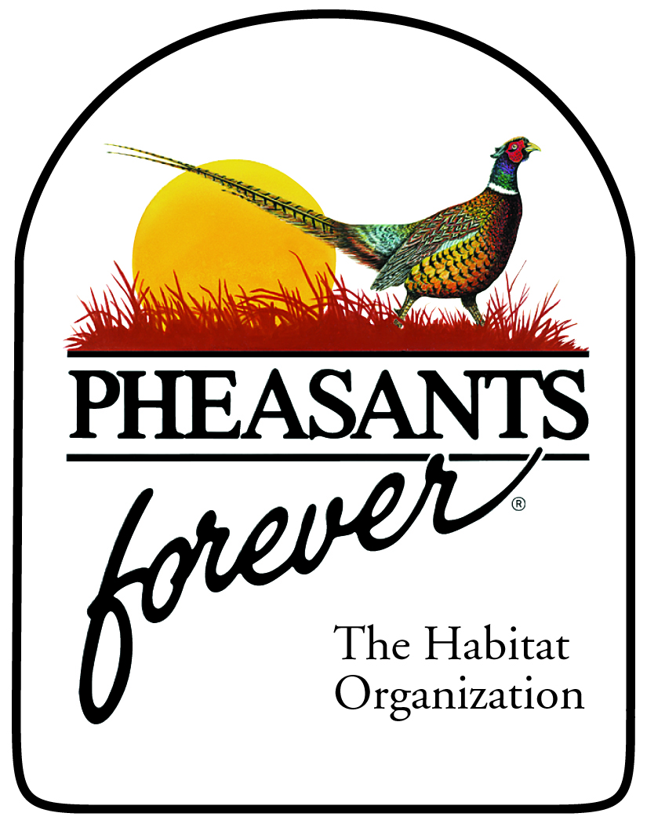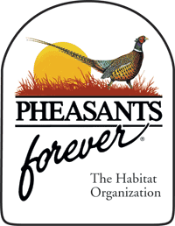

DATE OF YOUTH HUNT: October 18, 2025

I understand that hunting is a sport involving firearms. Firearms, when mishandled, can be dangerous. Further, I understand that it is incumbent upon me to use the utmost care in the exercise of hunting safety and firearm safety. I intend to do so and realize that I have an affirmative duty to do so.

I further realize that Pheasants Forever, their members, agents, employees, licensees, volunteers and associates are participating in this hunt to give me a quality outdoor experience. This participation by the referenced individuals will include travel to certain hunting areas. It also includes hunting with dogs. I understand that I will conduct myself in a manner as to be safe around all of the individuals mentioned herein and their dogs.

Further, I hereby waive all right to any claim, cause of action, right of litigation of any kind, whatsoever, originating from the October 18, 2025 Carroll County Youth Hunt and thereafter for all time as to Pheasants Forever, AVAD, The Carroll County Chapter of Pheasants Forever, members, employees, volunteers, licensees of said organization and their agents.

I realize it is a privilege to participate in this Youth Hunt and accordingly, I will conduct myself in a safe manner consistent with all affirmative duties which I have heretofore recognized.

Participant’s Name

_____________________________________________ ______________
Parent or Natural Guardian of Participant Date

Participant will be using
_____12 ga shotgun
_____20 ga shotgun

