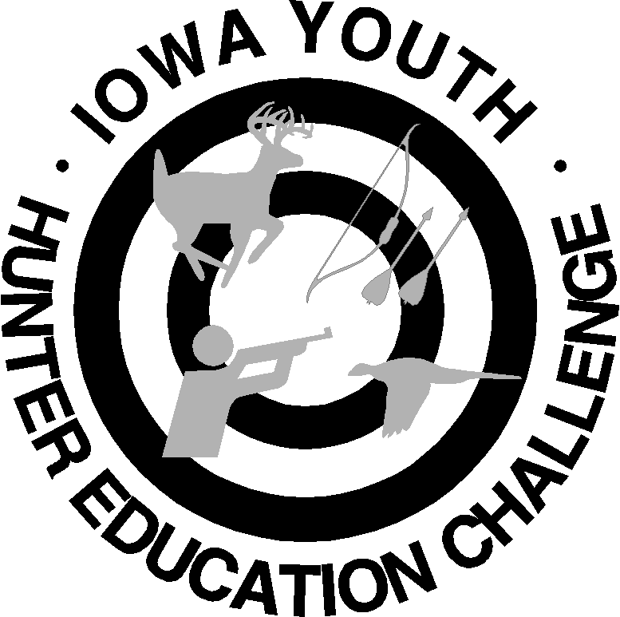
Liability/Medical Form
Check One: Coach Volunteer
Iowa State (NRA)
Youth Hunter Education Challenge

Personal Information (please print clearly)
Last Name: _______________________ First: _______________________ M.I. ____ T-Shirt Size: _____
Street Address: _________________________________ City: _______________________ State: _______ Zip: _________
Phone: ______________________ Email (for main correspondence): _________________________
Number of year(s) in the program: ______

Emergency Contact (first & last name): ________________________________ Relationship: __________________
Phone: ______________________________ Health Insurance Provider: ______________________________________
I give permission for emergency medical personnel to perform medical treatment for illness or accident if I am unable to do so. Yes No
Special Medical Considerations (i.e., medications, allergies, physical accommodations): ____________________________________________________________________________________________________________________________________________________________________________________________________________________
For event volunteers ONLY (not for coaches):
Choose your top three elements you are willing to help with at the event (muzzleloader, .22 rifle, archery, shotgun, wildlife ID, orienteering, safety trail or written exam).
- ___________________________
- ___________________________
- ___________________________
Are you a Hunter Safety Instructor in the state of Iowa? Yes No
For event coaches ONLY:
Choose which team you will be coaching Junior (11-14) Senior (15-18)
Please provide a team name: ________________________________________________
Please provide the name and the age of your team members.
- ______________________________________
- ______________________________________
- ______________________________________
- ______________________________________
- ______________________________________

(Continue on back)
Liability/Medical Release:
If injured while traveling to or from (by public, private, or any other means of conveyance) or while residing at and participating in any/all programs at the Iowa State YHEC; (1) Volunteer/Coach and/or family agrees to waive any legal claim against the NRA, its officers, employees, agents, servants, state sponsors or host. Volunteer/Coach hereby expressly assumes any and all risks associated with the activities contemplated hereunder, including, but not limited to, any and all risks associated with discharge of firearms and other outdoor activities. Volunteer/Coach (and their families) agree to indemnify, defend and hold harmless from and against any and all losses, expenses, damages, injuries and liabilities and claims (including attorney's fees, court costs and settlement costs) arising out of or relating to coach's/volunteer's breach of this Release or any act or omission of participant whatsoever; (2) Volunteer/Coach hereby gives consent for the NRA/Local/State/Provincial-level Sponsor to provide medical/athletic training attentions, transportation and emergency medical services as warranted. If the program includes physiological and/or biomechanical evaluations, further consent is given to these evaluations which pose no unusual risks or hazards when customary safeguards are observed. In signing this release, it is sworn that coach/volunteer member is in good physical condition and is not aware of any disease or injury that would result in injury during program participation. If you are less than 18 years of age or a minor under the laws of the state where I live, parents or legal guardian shall sign this release.
I understand that as a registered participant at the NRA Youth Hunter Education Challenge, I will not possess or consume ALCOHOLIC BEVERAGES or illegal DRUGS on the premises. I further understand and agree and abide by the general rules of conduct prescribed for guests of the Local/State/Provincial NRA YHEC and that violations will result in a denial of NRA Youth Hunter Education Challenge privileges. I understand that photographs may be taken during the program and may be used in the future to chronicle and publicize the program.

By signing this Release and Waiver of Liability, I state that I have read and understand the conditions set forth in this Release and that I agree to all conditions set forth herein, and that I sign this voluntarily.

Signature of Volunteer/Coach: Date:

Return form via email to jschmidt@clintoncounty-ia.gov
Or mail to:
CCCB, Attn: Jill Schmidt
PO Box 68
Grand Mound, IA 52751

Note: Each individual team member will register and make payment for themselves online. No payment is needed for volunteers and coaches, just the paperwork turned in.

